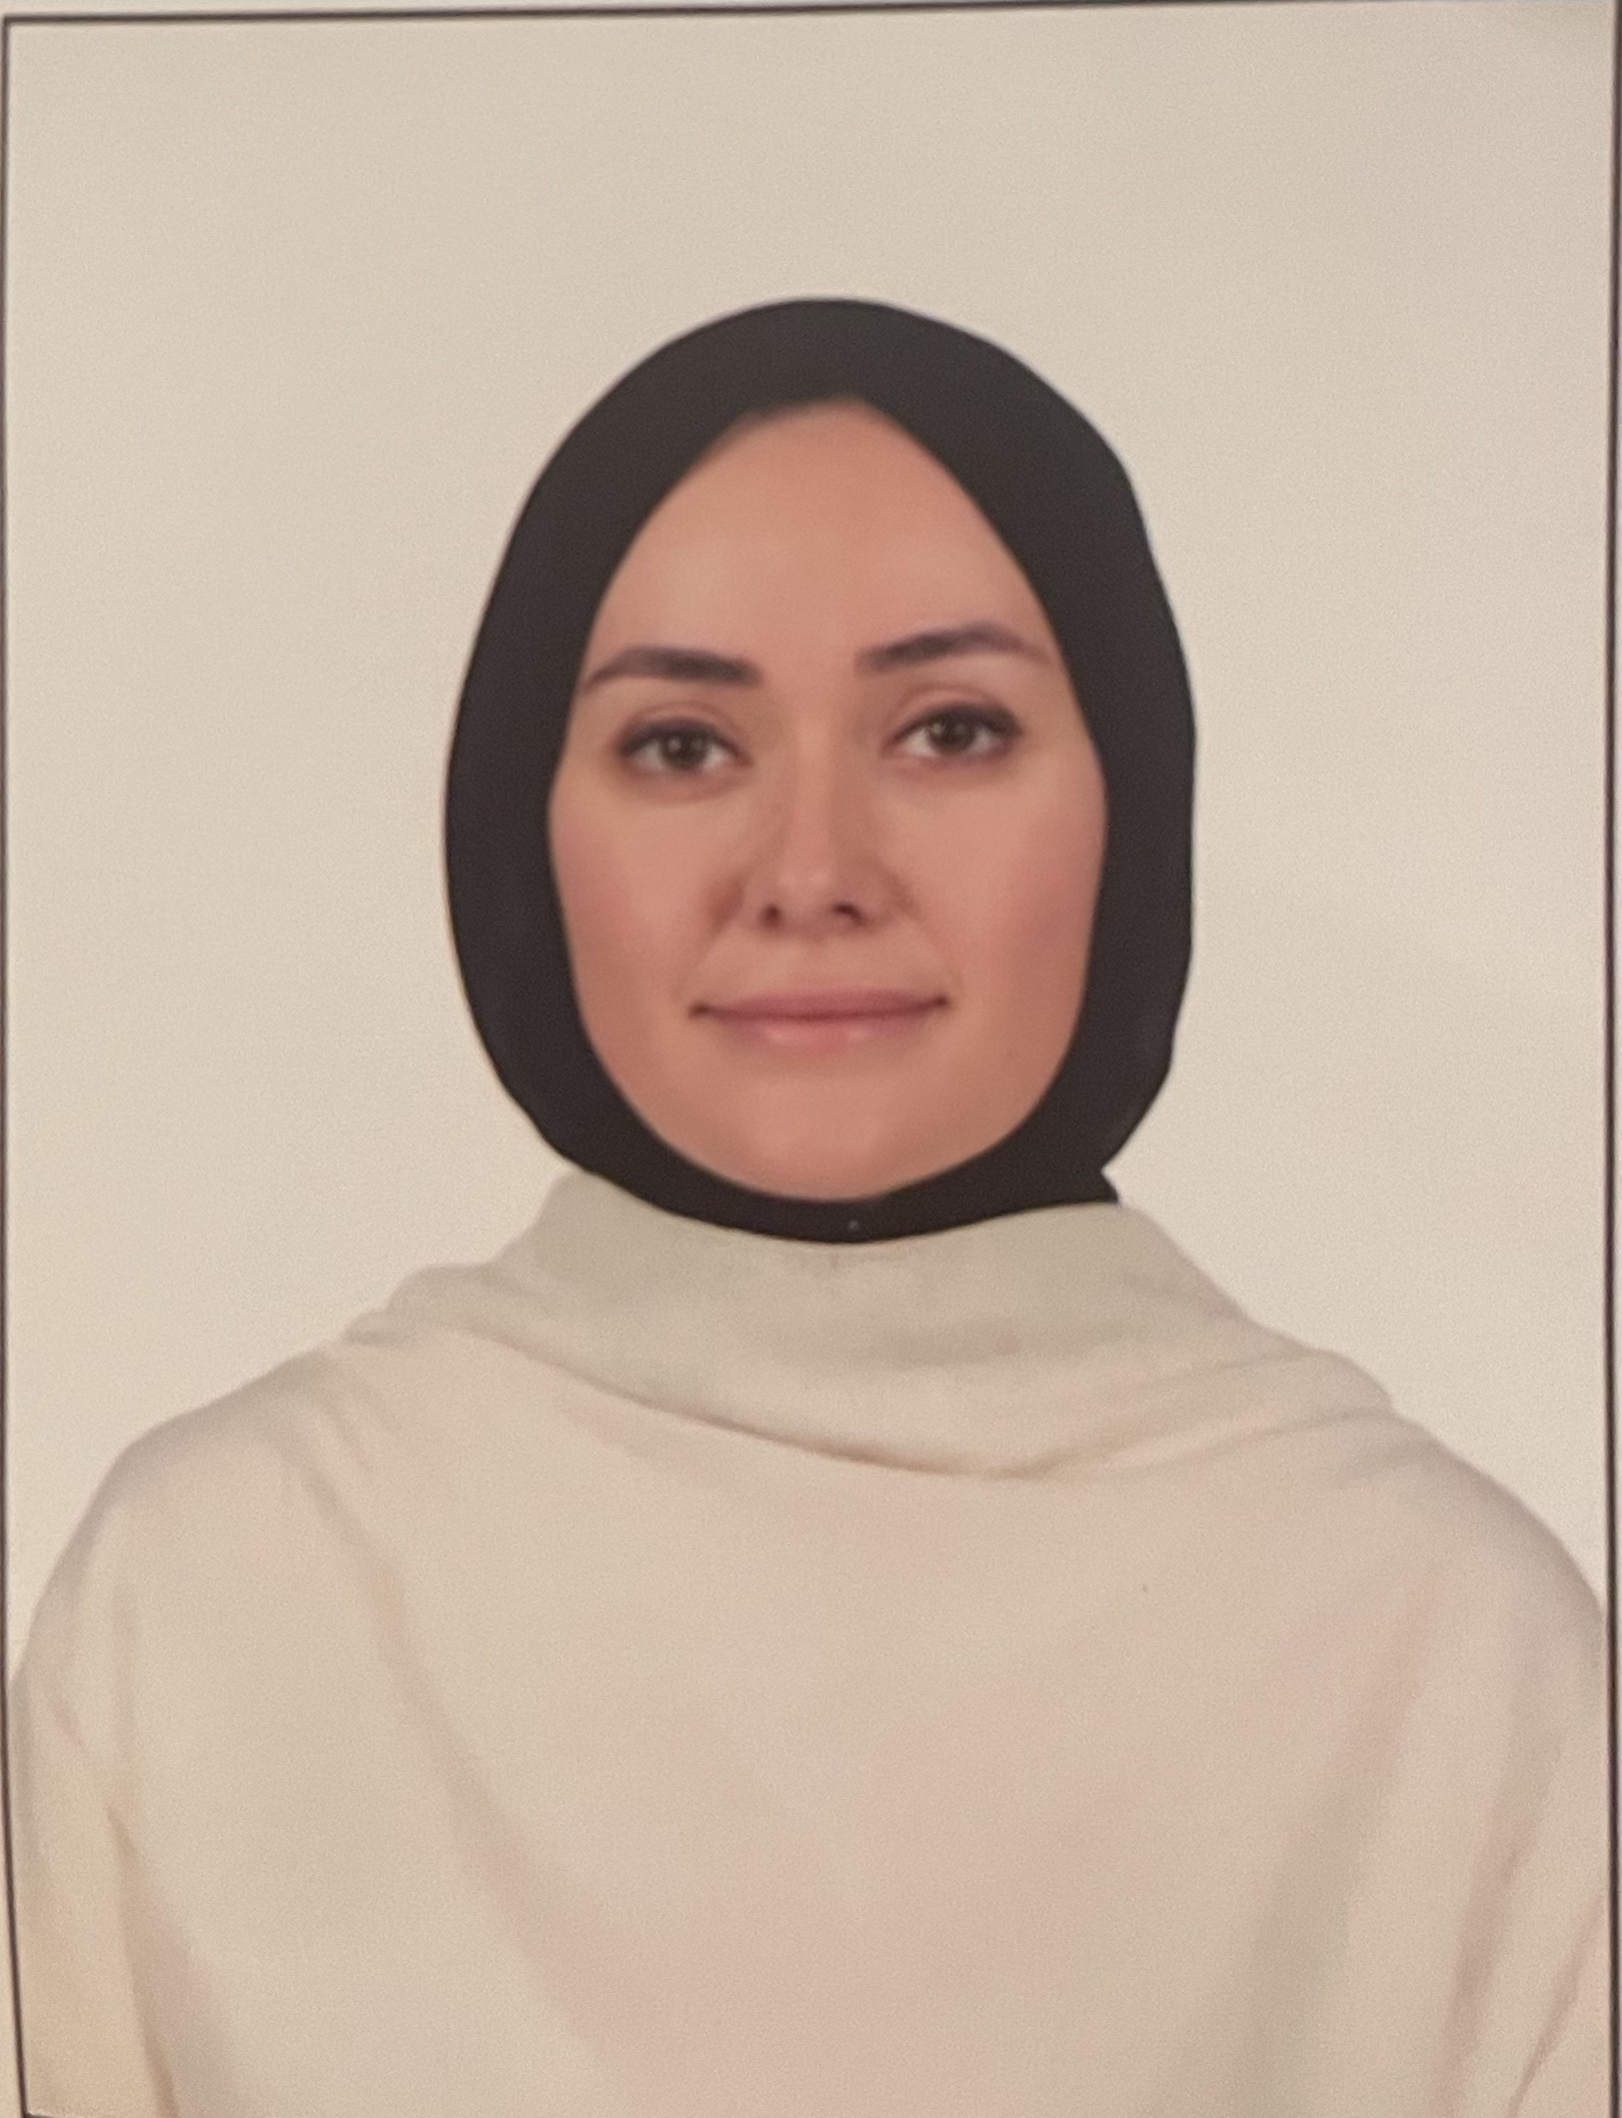

Doç.Dr. Sema ÜSTÜN KÜLÜNK

Department of Translation & Interpreting Studies
Boğaziçi University 34342 Bebek Istanbul, TURKEY
e-mail: semaustunsema@gmail.com

EDUCATION:__________________________________________________________________________
PhD in Translation Studies, Boğaziçi University, 2013-2019. Title of the thesis: Recontextualizing Turkish Islamist Discourse: Hilal (1958-1980) as a Site of Translational Repertoire Construction.

MA in Translation Studies, Boğaziçi University, 2010-2013. Title of the thesis: A Historical and Conceptual Analysis of the Terms used in the Titles of Turkish Qur’an Translations since 1923 (with a Supplementary Bibliography of the Translations).

BA in Translation and Interpreting Studies, Boğaziçi University, 2006-2010.
FURTHER EDUCATION: ______________________________________________________________
CELTA (Certificate in Teaching English to Speakers of Other Languages), University of Cambridge / British Side 2012.

RESEARCH LANGUAGES: _____________________________________________________________
Turkish (mother tongue), English (fluent), French (intermediate), Ottoman Turkish (intermediate), Arabic (pre-intermediate).

AREAS OF RESEARCH:________________________________________________________________
Translation history, ideological translation, retranslation, fictional translation, Qur’an translations, translation agency, religious translations, migration and translation, refugee translations, and media studies.

ACADEMIC POSITIONS: _______________________________________________________________
- 2021- 2024/Doğus University
Department of Translation and Interpreting Studies, Asst. Prof.

- 2017-2019/ Hacettepe University
Department of Translation and Interpreting Studies, Research Asst.

- 2012-2016/ Boğaziçi University
Department of Translation and Interpreting Studies, Research Asst.

- 2011-2012/ Kültür University
School of Foreign Languages, Instructor

- 2010-2011/ Yeni Yüzyıl University
School of Foreign Languages, Instructor

PUBLICATION LIST___________________________________________________________________

BOOK CHAPTER(S):
Üstün Külünk, Sema. (2023). A Kurdish Translator’s Badge in Türkiye – An Identity Card or a False ID: Çevirmen as a Translatorial Autobiography. In S. Sancaktaroğlu Bozkurt & T.E. Taşdan Doğan (Eds.), Translation Studies: Translating in the 21st Century Multiple Identities (pp. 111-125). Berlin: Peter Lang.

ARTICLES:
Üstün Külünk, Sema. (2023). Translating Islam(ism) for a Muslim society: a novel ‘Intra Ummah translation paradigm’ for Islamist translations in Turkey, Perspectives, DOI: 10.1080/0907676X.2023.2281969 (SSCI).

Üstün Külünk, Sema. (2023). The Novel Mütercim as a Site of Transfiction: A Case of Translation in Life and the Translation of Life in the Transformational Republican Era in Turkey. Translation & Interpreting, 15 (1), 236-252.

Üstün Külünk, Sema. (2023). Integrating Translation into Periodical Studies: Unveiling Translatorial Insights Through Bı̇rgün Kı̇tap and Yenı̇ Şafak Kı̇tap. Türki̇ye Sosyal Araştirmalar Dergi̇si̇, 27 (3), 667-680.

Üstün Külünk, Sema. (2023). Exploring Translation Criticism: A Comparative Analysis of the Translation of the Novella the Strange Case of Dr. Jekyll and Mr. Hyde (1985) as Dr. Jekyll ve Mr. Hyde (2009) in Turkish. Dil ve Edebiyat Araştırmaları, 28, 186-201.

Üstün Külünk, Sema. (2023). When Particular Contexts Create Their Concepts: The Evolution of Meal as a Canonical Translational Term for Qur'an Translations in Türkiye. İstanbul Üniversitesi Çeviribilim Dergisi - Istanbul University Journal of Translation Studies, 18, 149-165.

Üstün Külünk, Sema. (2023). The intricate zone of hadith translations: navigating between translators, compilers, and intermediaries in Türkiye. RumeliDE Journal of Language and Literature Studies, 36 (1), 1576-1590.

Üstün Külünk, Sema. (2022). The Uncharted Experience of Female Qur’an Translators in Turkey. Parallèles, 34 (1), 141-152. DOI:10.17462/para.2022.01.12

Üstün Külünk, Sema. (2020). The Discourse on the Praxis and Pragmatics of the Qur’an Retranslations in Turkish. TranscUlturAl, 12 (1), 75-98. DOI: https://doi.org/10.21992/tc29463

Üstün Külünk, Sema. (2019). When The Enchantress of Florence is Turned into Floransa Büyücüsü: Translation Under the Gaze of Stylistic Analysis. Folklor Edebiyat, 98 (25), 353-369.

Üstün Külünk, Sema. (2019). The Kite Runner and its Film Adaptation as a Site of Intersemiotic Translation. MOLESTO-Edebiyat Araştırmaları Dergisi, 5 (1), 72-90.

Üstün Külünk, Sema. (2018). Reading Works of Tanpınar and Pamuk on İstanbul as Intersemiotic City Translations. Folklor Edebiyat, 95 (24-August), 213-239.
DOI: http://dx.doi.org/10.22559/folklor.349

Üstün Külünk, Sema. (2018). Bir Kültürel Değişim Öznesi Olarak Tüccarzade İbrahim Hilmi Çığıraçan ve 1896-1963 Yılları Arasındaki Yayıncılık Faaliyetlerinde Tercüme Üzerine Söylemi. Çeviribilim ve Uygulamaları Dergisi, 25 (Spring).

Üstün, Sema. (2016). Cumhuriyetin İlanından Günümüze Kur’an Tercümeleri Üzerine. Türkiye Araştırmaları Literatür Dergisi (TALİD), 10 (19), 229-253.

CONFERENCE PRESENTATIONS:
Üstün Külünk, Sema. (2023). “The Identity Crisis of Translators in Cases of Real-Life Crisis: A Visit to The Pragmatics of Translation in a Refugee Context in Türkiye”. International Ahlat Scientific Research Congress, (15-16 August), Turkey.

Üstün Külünk, Sema. (2023). “Redefining (?) Womanhood through Hadith Translations: A Glance over the Cases in Turkey”. Boğazi̇çi̇ Scientific Studies Congress, (19-20 September), İstanbul, Turkey.

Üstün Külünk, Sema. (2023). “At the Juncture of Adaptation Studies and Intersemiotic Translation: A Case Study on ‘Anne with an E’ vis-a-vis ‘Yeşıl Vadinin Kızı’”. 8th International Aegean Conferences on Social Sciences & Humanities, (23-25 September), İzmir, Turkey.

Üstün Külünk, Sema. (2022). “Translational Discourse as a Means of Analyzing Socio-Cultural Transformation: The Case of Namık Kemal (1840-1888) as a Cultural Agent of Change”. In the ICENSOS (December 20 – 23), Konya, Turkey.

Üstün Külünk, Sema. (2019). “Tercüme Odaklı Repertuvar İnşası ile Türk İslamcılığının Yeni Bir Bağlam Kazanması: İslamcı Tercüme-Metin Üretim Alanı Olarak 1960-1980 Döneminde Hilal Dergisi.” In the Elif Daldeniz Baysan Lisansüstü Çalışmalar Kolokyumu, Okan University, İstanbul-Turkey.

Üstün Külünk, Sema. (2018). “Re-Reading Turkish Islamism in Translation History and its Repercussions on Translational Practices between 1960-1980.” In the Symposium of Enriching Translation Studies through Re-readings, March 28, 2018, 29 Mayıs University, İstanbul-Turkey.

Üstün, Sema. (2015). “Bir Kültürel Değişim Öznesi Olarak Tüccarzade İbrahim Hilmi Çığıraçan ve 1896-1963 Yılları Arasındaki Yayıncılık Faaliyetlerinde Tercüme Üzerine Söylemi”. In the Elif Daldeniz Baysan Lisansüstü Çalışmalar Kolokyumu, April 3, 2015, Okan University, İstanbul-Turkey.

Üstün, Sema. (2014). “A Historical and Conceptual Analysis of the Terms Used in the Titles of Turkish Qur’an Translations.” In the International Conference on Qur’an Translations, December 13-17, 2014, Allameh Tabataba’i University, Tehran-Iran.

Üstün, Sema. (2013). “Translation of the Sacred Untranslatable: Retranslations of the Qur’an in Turkish since 1923.” In the International Retranslation Conference, 2013, Boğazici University, İstanbul-Turkey.

COURSES TAUGHT _________________________________________________________
Oral Communication Skills
Written Communication Skills
Translating Texts on Economics and Trade
Translating Texts on Politics
Presentation Skills
Theoretical Approaches to Translation
Research and Writing

